US Housing Statistics
Input for Positive Money US web site
Table of Contents

Number of US Owner Occupied Housing Units from 2007 - 2012 2
Search Query used in Wolfram Alpha 3
US Housing Prices 1997-2015 4
Search Query used in Wolfram Alpha 4
US Median Home Price 1989-2013 5
Search Query used in Wolfram Alpha 6
US Home Price Yearly Change 1990-2013 7
Search Query used in Wolfram Alpha 8
US Median Home Value 2007–2012 9
Search Query used in Wolfram Alpha 10
US Median Home Value Distribution by Household Income 2010-2012 11
Search Query used in Wolfram Alpha 11
US Aggregate Home Value 2007-2012 12
Search Query used in Wolfram Alpha 12
Number of US Households from 2009 – 2012 13
Search Query used in Wolfram Alpha 13
Number of US Households by State 14
Search Query used in Wolfram Alpha 14
US Households by Income Distribution from 2008 – 2012 15
Search Query used in Wolfram Alpha 17

Number of US Owner Occupied Housing Units from 2007 - 2012

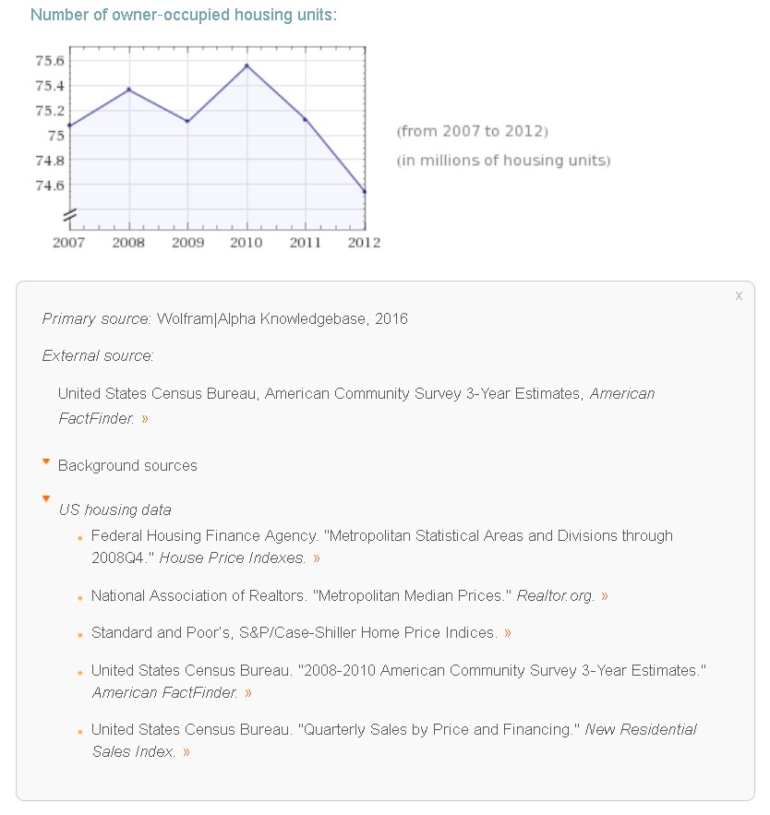

Number of Owner Occupied US Housing Units
Date | Units (millions)
1/1/2007 | 75.07
1/1/2008 | 75.36
1/1/2009 | 75.11
1/1/2010 | 75.56
1/1/2011 | 75.12
1/1/2012 | 74.54

Search Query used in Wolfram Alpha
United States number of housing units
Option = Assuming “number of housing units” is referring to US housing data

US Housing Prices 1997-2015

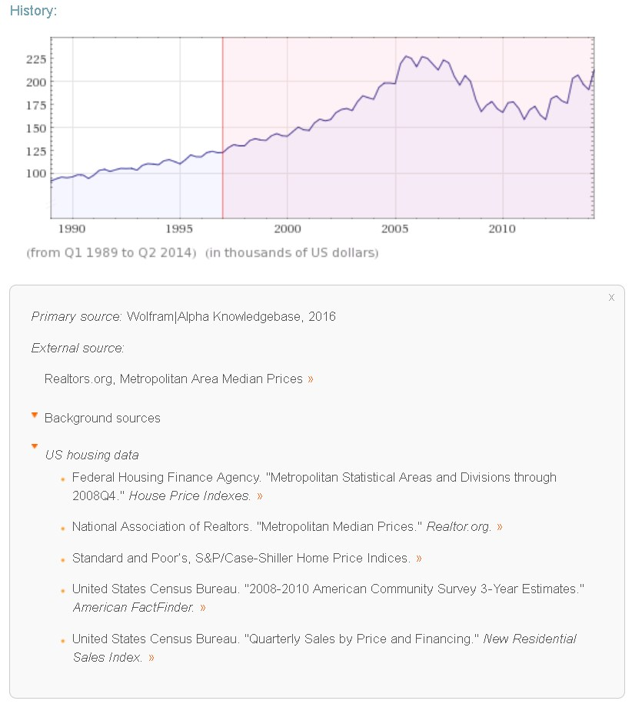

Search Query used in Wolfram Alpha
United States housing prices from 1997

US Median Home Price 1989-2013

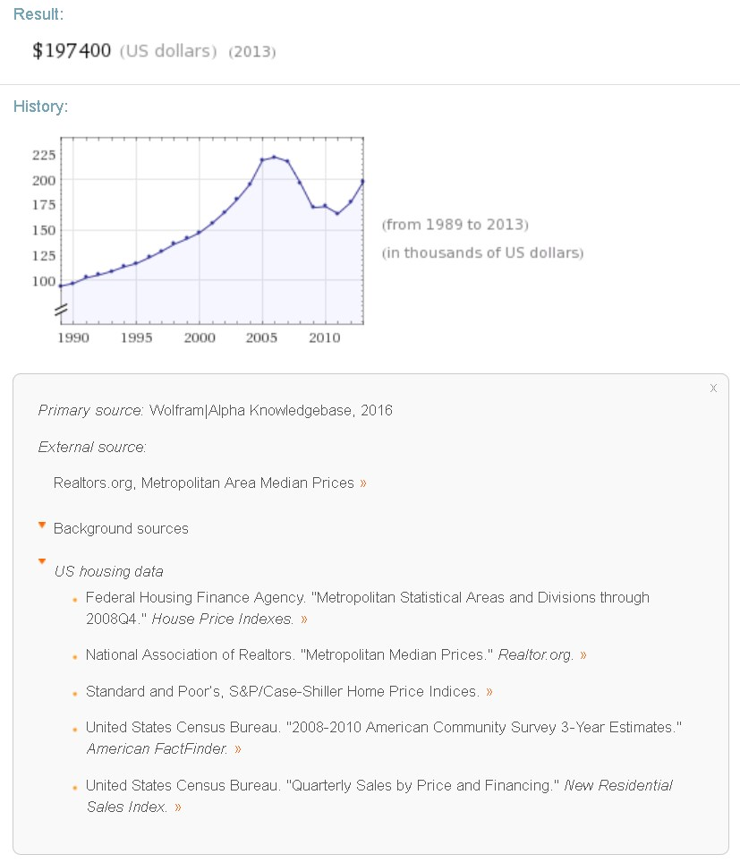

US Median Home Price
Date | Dollars (thousands)
1/1/1989 | 94.6
1/1/1990 | 97.3
1/1/1991 | 102.7
1/1/1992 | 105.5
1/1/1993 | 109.1
1/1/1994 | 113.5
1/1/1995 | 117.0
1/1/1996 | 122.6
1/1/1997 | 129.0
1/1/1998 | 136.0
1/1/1999 | 141.2
1/1/2000 | 147.3
1/1/2001 | 156.6
1/1/2002 | 167.6
1/1/2003 | 180.2
1/1/2004 | 195.2
1/1/2005 | 219.0
1/1/2006 | 221.9
1/1/2007 | 217.9
1/1/2008 | 196.6
1/1/2009 | 172.1
1/1/2010 | 173.1
1/1/2011 | 166.2
1/1/2012 | 177.2
1/1/2013 | 197.4

Search Query used in Wolfram Alpha
United States annual median home price

US Home Price Yearly Change 1990-2013
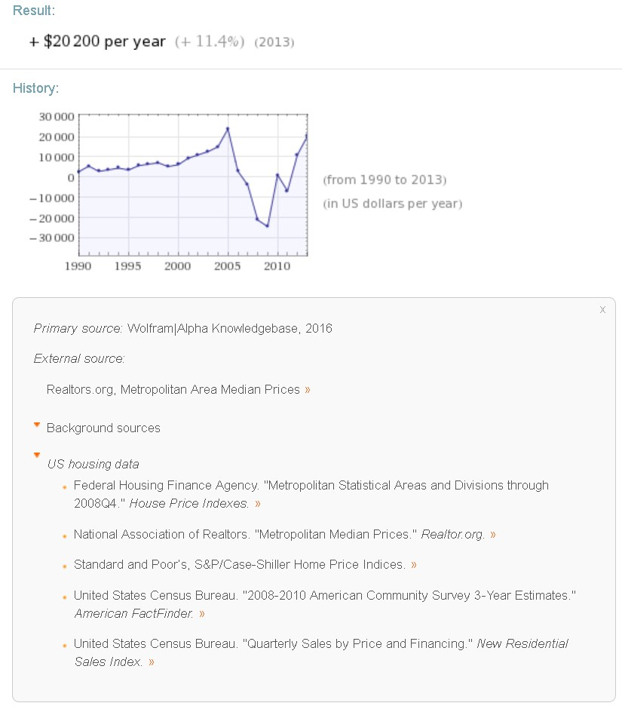

US Home Price Yearly Change
Date | Dollar Change per year
1/1/1990 | 2700
1/1/1991 | 5400
1/1/1992 | 2800
1/1/1993 | 3600
1/1/1994 | 4400
1/1/1995 | 3500
1/1/1996 | 5600
1/1/1997 | 6400
1/1/1998 | 7000
1/1/1999 | 5200
1/1/2000 | 6100
1/1/2001 | 9300
1/1/2002 | 11000
1/1/2003 | 12600
1/1/2004 | 15000
1/1/2005 | 23800
1/1/2006 | 2900
1/1/2007 | -4000
1/1/2008 | -21300
1/1/2009 | -24500
1/1/2010 | 1000
1/1/2011 | -6900
1/1/2012 | 11000
1/1/2013 | 20200

Search Query used in Wolfram Alpha
United States annual median home price
Highlight the map and click on “Data Download”

US Median Home Value 2007–2012

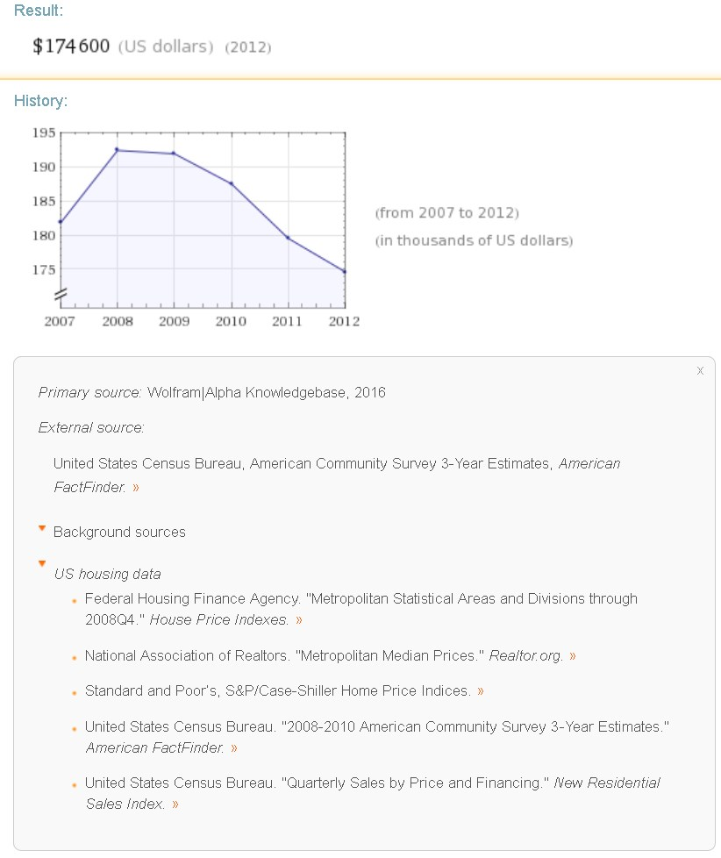

US Median Home Value 2007-2012
Date | Dollars (thousands)
1/1/2007 | 181.8
1/1/2008 | 194.4
1/1/2009 | 191.9
1/1/2010 | 187.5
1/1/2011 | 179.5
1/1/2012 | 174.6

Search Query used in Wolfram Alpha
United States median home value
Highlight the map and click on “Data Download”

US Median Home Value Distribution by Household Income 2010-2012

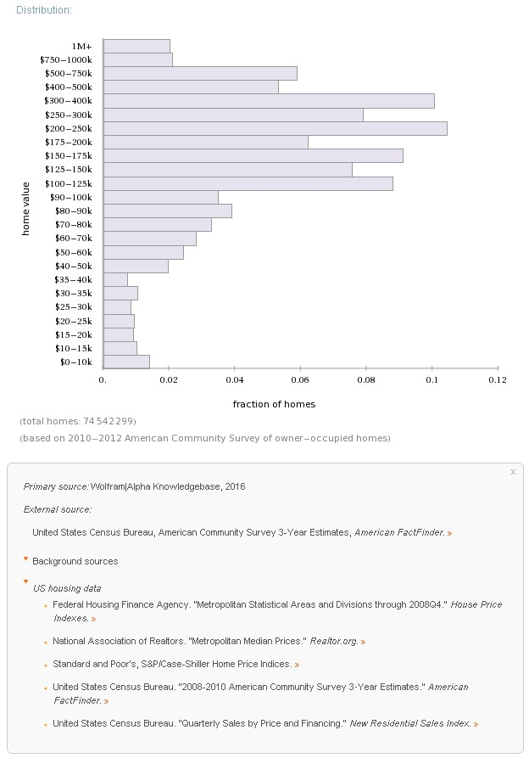

Search Query used in Wolfram Alpha
United States median home value

US Aggregate Home Value 2007-2012

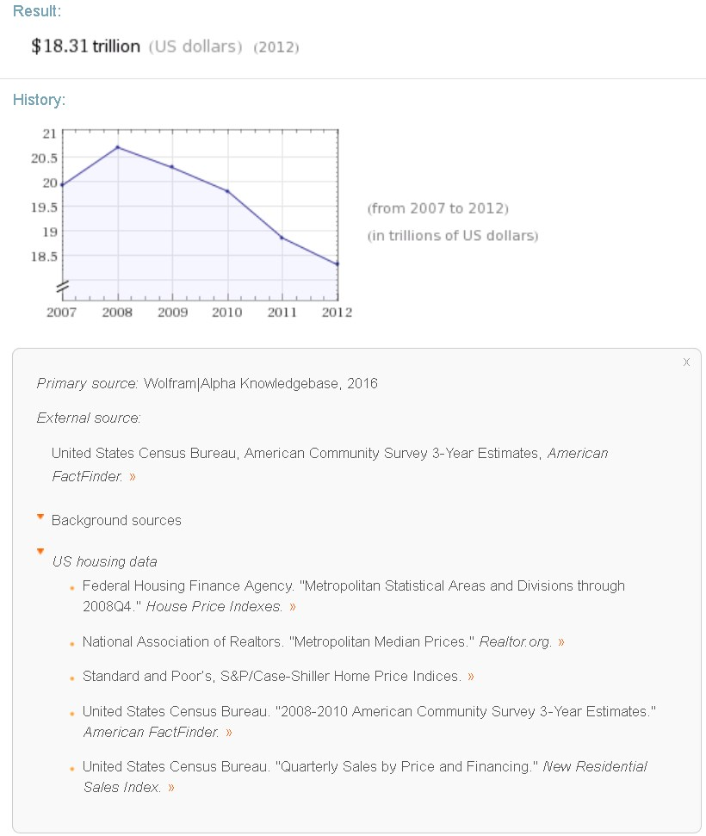

Search Query used in Wolfram Alpha
United States aggregate home value

Number of US Households from 2009 – 2012

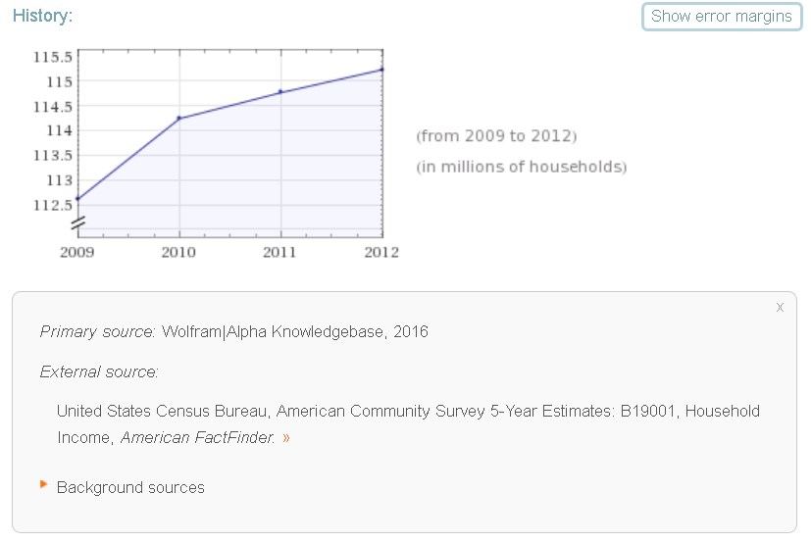
Number of US Households 2009-2012
Date | Units (millions)
1/1/2009 | 112.6
1/1/2010 | 114.2
1/1/2011 | 114.8
1/1/2012 | 115.2

Search Query used in Wolfram Alpha
United States number of housing units
Option = Assuming “number of housing units” is referring to American Community Survey estimates

Number of US Households by State

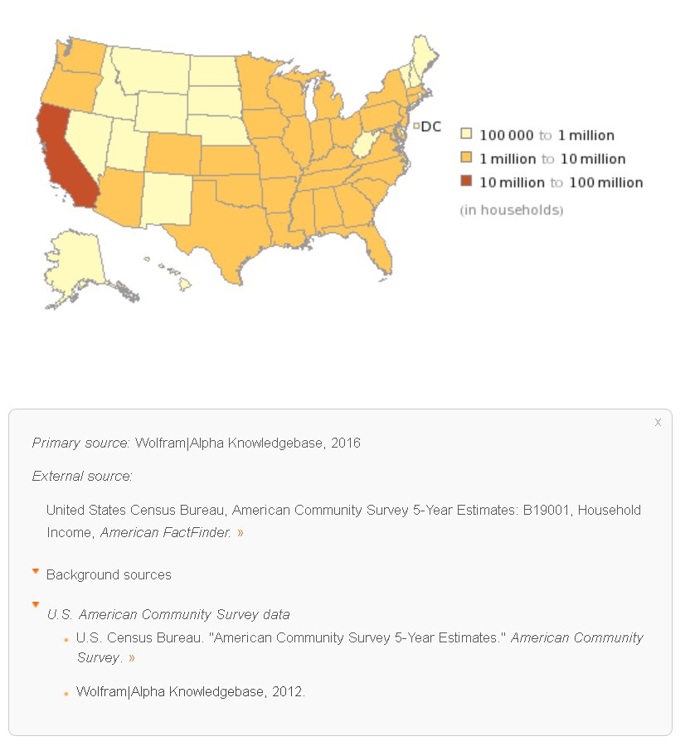

Search Query used in Wolfram Alpha
United States number of housing units
Option = Assuming “number of housing units” is referring to American Community Survey estimates

US Households by Income Distribution from 2008 – 2012

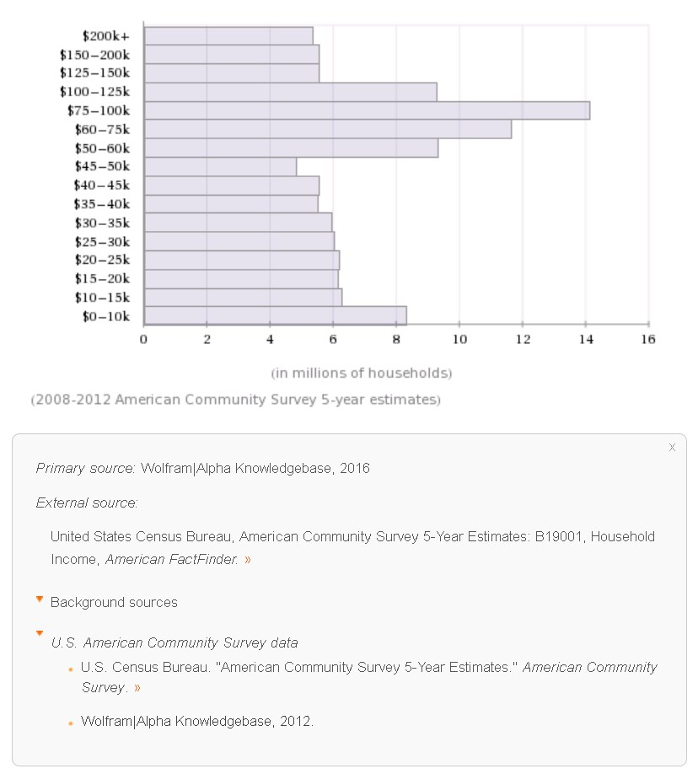
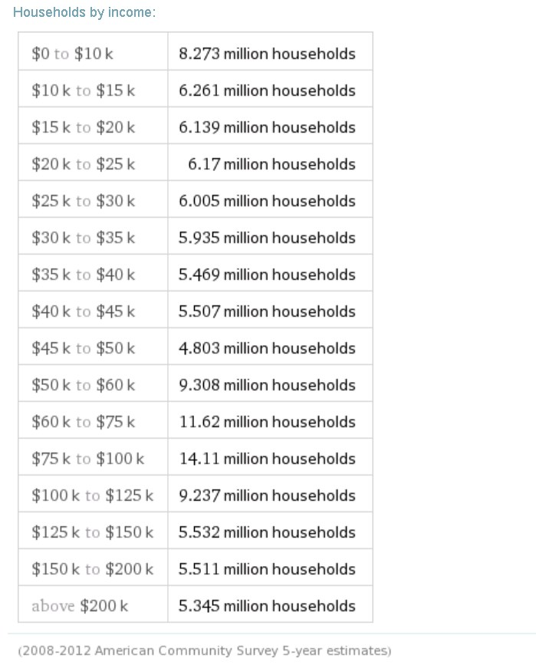

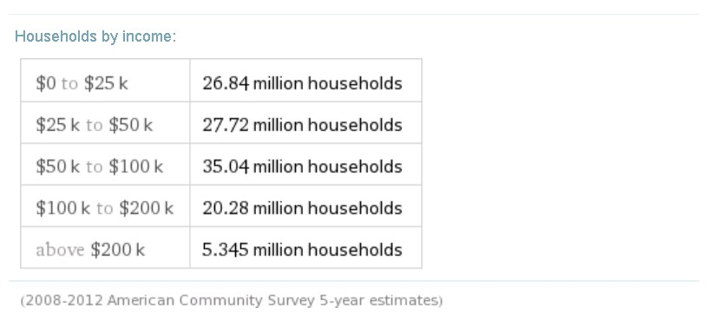

Search Query used in Wolfram Alpha
United States number of housing units
Option = Assuming “number of housing units” is referring to American Community Survey estimates

